Perpendicular Bisector Theorem
# Source: AI Source: Provided by: [Data Path: Persons Table -> ID Column: 1, Name_En Column: Motasem Essam] -> From: [ChatGPT] on [7/25/2026]
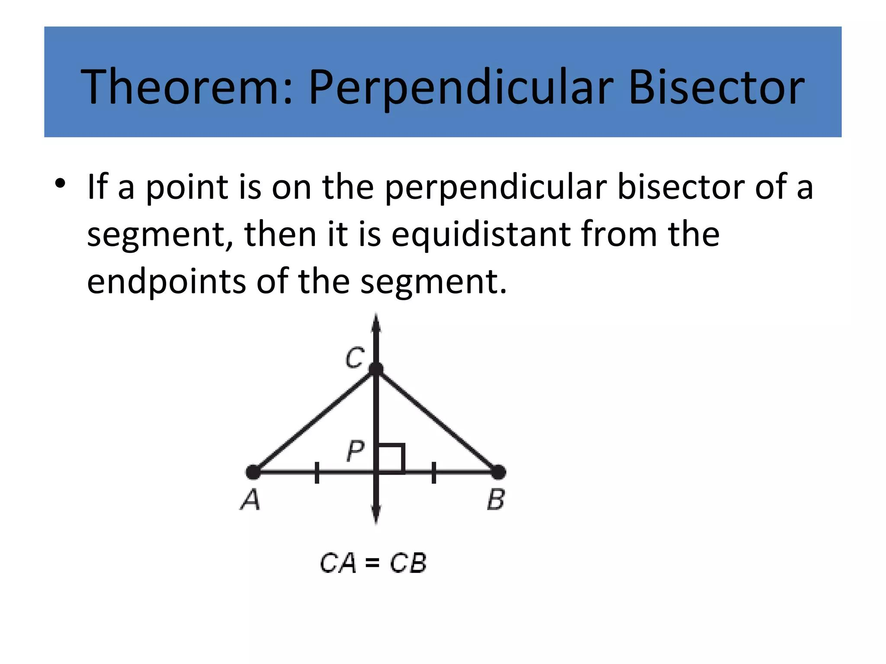
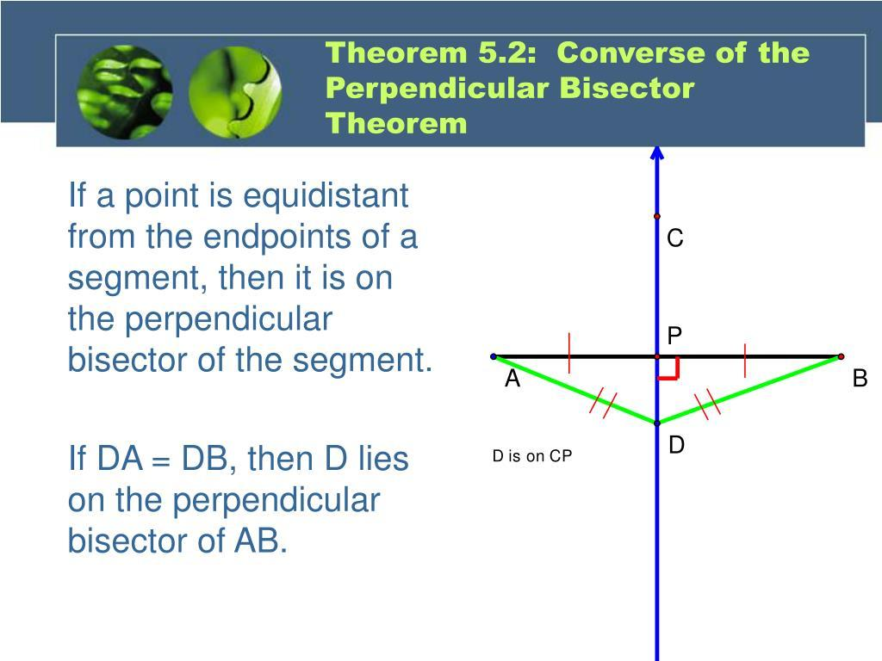
​
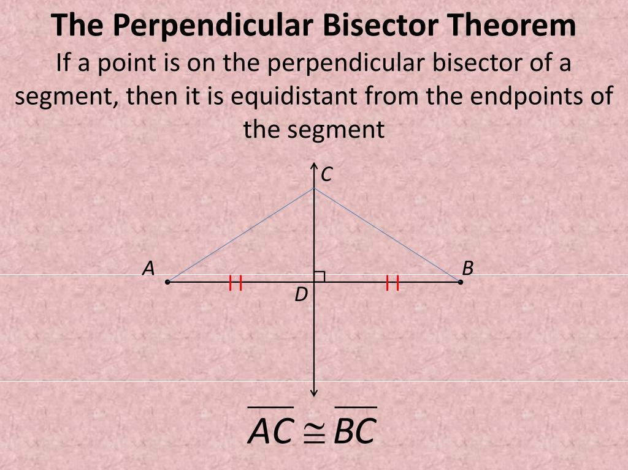

Definition
# Source: AI Source: Provided by: [Data Path: Persons Table -> ID Column: 1, Name_En Column: Motasem Essam] -> From: [ChatGPT] on [7/25/2026]
The Perpendicular Bisector Theorem states:
Any point on the perpendicular bisector of a line segment is equidistant from the two endpoints of that segment.
Consider line segment $\overline{AB}$. Let $M$ be its midpoint, and let line $l$ be perpendicular to $AB$ at $M$.
If $P$ is any point on $l$, then:
$$\boxed{PA=PB}$$
Therefore, every point on the perpendicular bisector of $\overline{AB}$ is the same distance from $A$ and $B$.

Basic Configuration
# Source: AI Source: Provided by: [Data Path: Persons Table -> ID Column: 1, Name_En Column: Motasem Essam] -> From: [ChatGPT] on [7/25/2026]
Suppose:
$$AM=MB$$
and:
$$PM⟂AB$$
Then $PM$ is the perpendicular bisector of $\overline{AB}$.
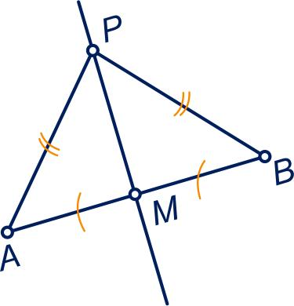
Image
​
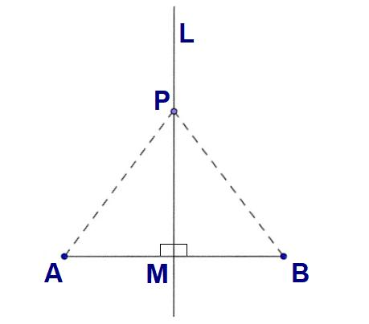
Image 2
​
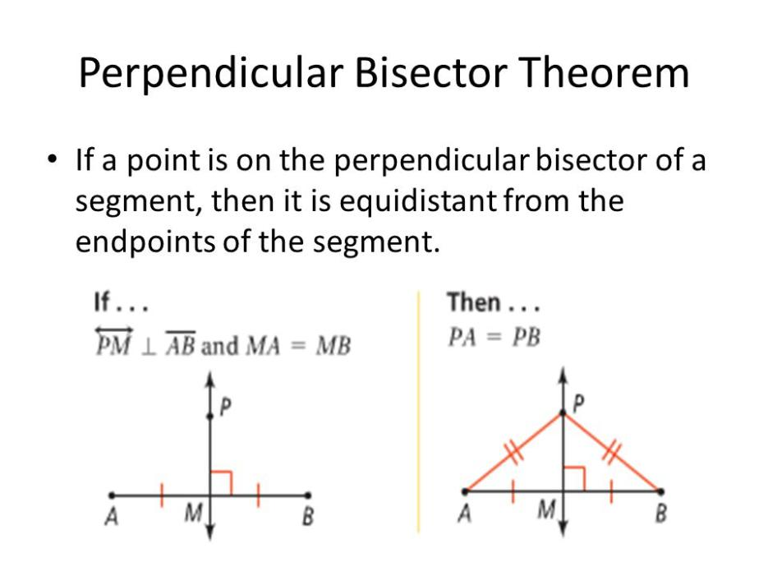
Image 3
​
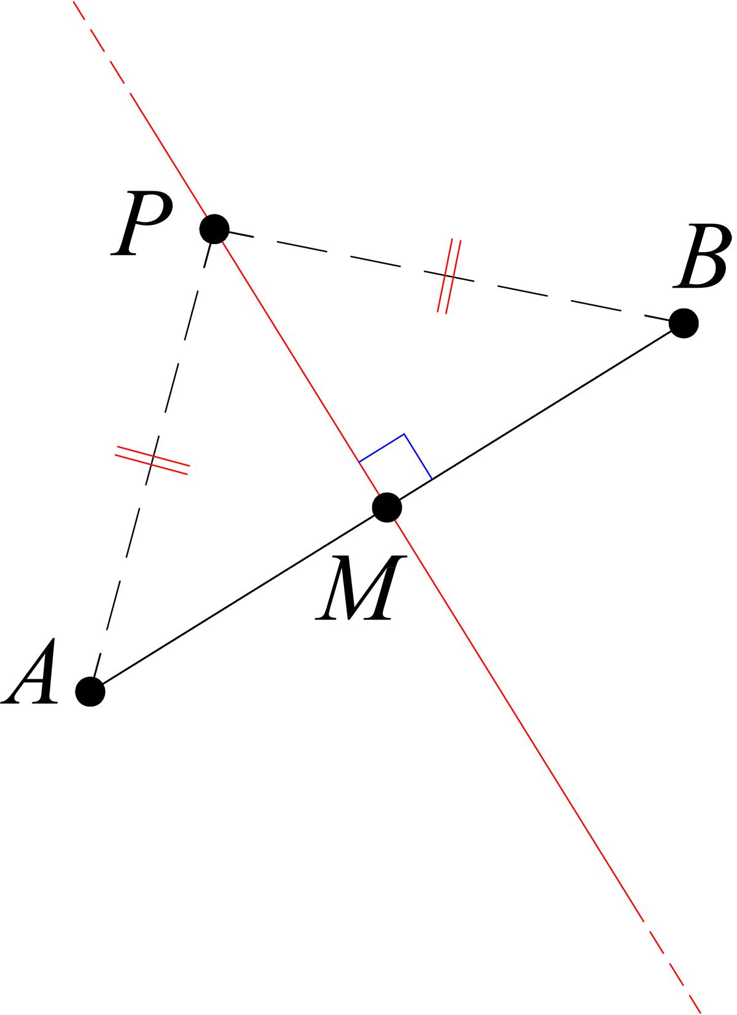
Image 4
​
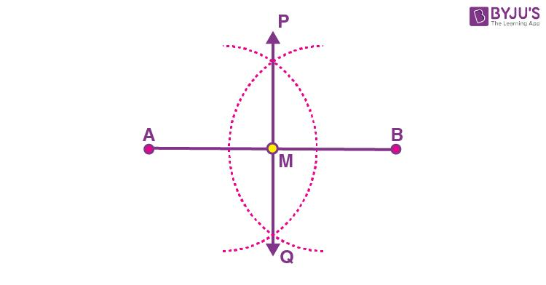
Image 5
Because $P$ lies on the perpendicular bisector:
$$\boxed{PA=PB}$$

Mathematical Representation
# Source: AI Source: Provided by: [Data Path: Persons Table -> ID Column: 1, Name_En Column: Motasem Essam] -> From: [ChatGPT] on [7/25/2026]
If $P$ lies on the perpendicular bisector of $\overline{AB}$:
$$\boxed{PA=PB}$$
In words:
$$\boxed{\text{Point on perpendicular bisector}⇒\text{equal distances from endpoints}}$$

Proof of the Perpendicular Bisector Theorem
# Source: AI Source: Provided by: [Data Path: Persons Table -> ID Column: 1, Name_En Column: Motasem Essam] -> From: [ChatGPT] on [7/25/2026]
Let:
- $M$ be the midpoint of $\overline{AB}$.
- $PM$ be perpendicular to $AB$.
Therefore:
$$AM=MB$$
and:
$$∠PMA=∠PMB={90}^{∘}$$
Consider triangles:
$$△PMA$$
and:
$$△PMB$$
We have:
$$AM=MB$$
$$PM=PM$$
and:
$$∠PMA=∠PMB$$
Therefore, by SAS congruence:
$$△PMA≅△PMB$$
Corresponding sides are equal:
$$\boxed{PA=PB}$$
Thus, the theorem is proved.

Converse of the Perpendicular Bisector Theorem
# Source: AI Source: Provided by: [Data Path: Persons Table -> ID Column: 1, Name_En Column: Motasem Essam] -> From: [ChatGPT] on [7/25/2026]
The converse reverses the direction.
Any point that is equidistant from the endpoints of a line segment lies on the perpendicular bisector of that segment.
If:
$$\boxed{PA=PB}$$
then $P$ lies on the perpendicular bisector of $\overline{AB}$.
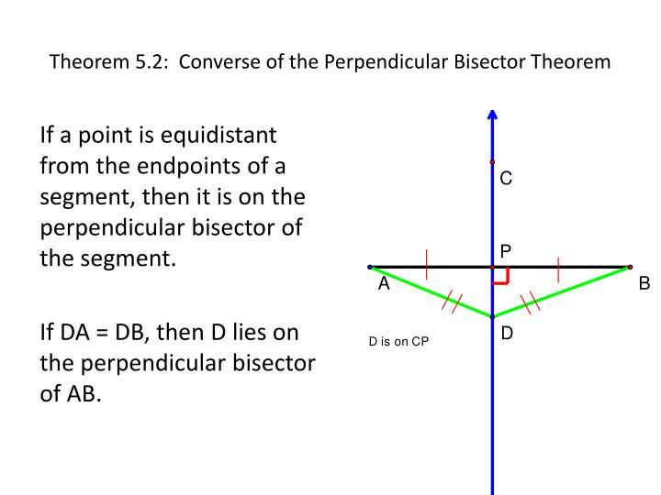
Image
​
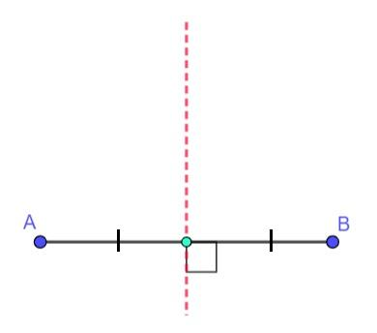
Image 2
​
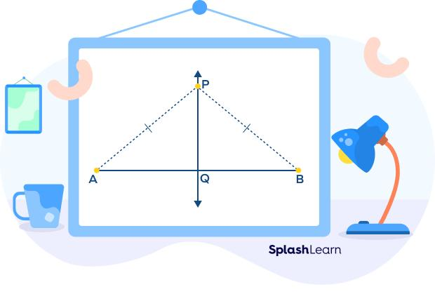
Image 3
​
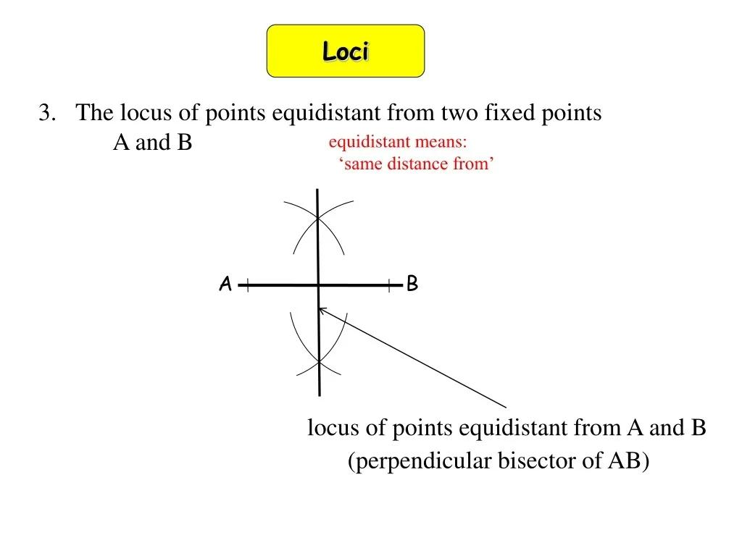
Image 4
​
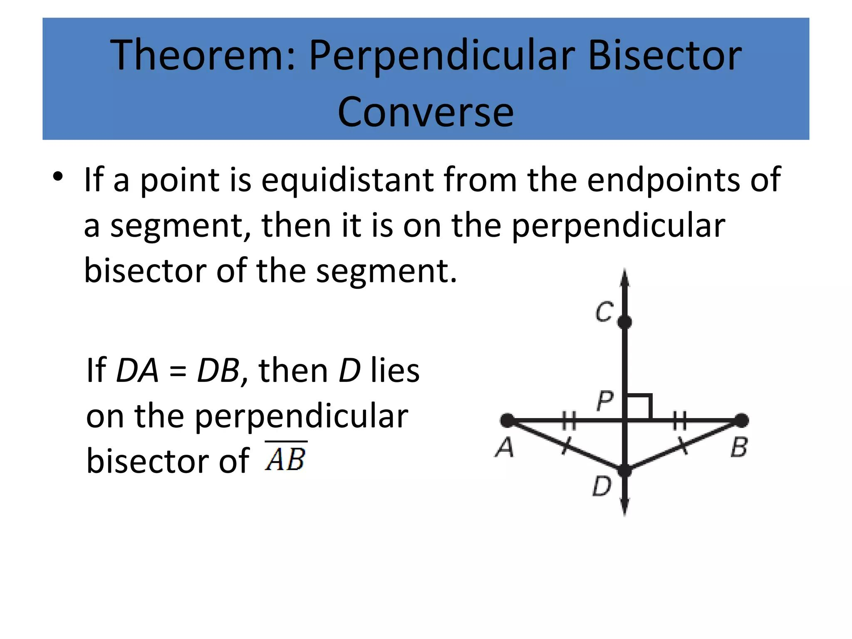
Image 5
Therefore:
$$\boxed{PA=PB⇒P\text{ lies on perpendicular bisector of }AB}$$

Theorem and Converse
# Source: AI Source: Provided by: [Data Path: Persons Table -> ID Column: 1, Name_En Column: Motasem Essam] -> From: [ChatGPT] on [7/25/2026]
These two statements are extremely important:

Perpendicular Bisector Theorem
# Source: AI Source: Provided by: [Data Path: Persons Table -> ID Column: 1, Name_En Column: Motasem Essam] -> From: [ChatGPT] on [7/25/2026]
$$\boxed{P\text{ on perpendicular bisector}⇒PA=PB}$$

Converse
# Source: AI Source: Provided by: [Data Path: Persons Table -> ID Column: 1, Name_En Column: Motasem Essam] -> From: [ChatGPT] on [7/25/2026]
$$\boxed{PA=PB⇒P\text{ on perpendicular bisector}}$$
Together:
$$\boxed{P\text{ lies on perpendicular bisector of }AB⇔PA=PB}$$

Example 1: Finding an Equal Distance
# Source: AI Source: Provided by: [Data Path: Persons Table -> ID Column: 1, Name_En Column: Motasem Essam] -> From: [ChatGPT] on [7/25/2026]
Suppose $P$ lies on the perpendicular bisector of $AB$, and:
$$PA=12\text{ cm}$$
By the Perpendicular Bisector Theorem:
$$PA=PB$$
Therefore:
$$\boxed{PB=12\text{ cm}}$$

Example 2: Identifying a Point on the Perpendicular Bisector
# Source: AI Source: Provided by: [Data Path: Persons Table -> ID Column: 1, Name_En Column: Motasem Essam] -> From: [ChatGPT] on [7/25/2026]
Suppose:
$$PA=9\text{ cm}$$
and:
$$PB=9\text{ cm}$$
Since:
$$PA=PB$$
the converse theorem tells us that:
$$\boxed{P\text{ lies on the perpendicular bisector of }AB}$$

Example 3: Finding a Missing Length
# Source: AI Source: Provided by: [Data Path: Persons Table -> ID Column: 1, Name_En Column: Motasem Essam] -> From: [ChatGPT] on [7/25/2026]
Suppose $P$ lies on the perpendicular bisector of $AB$.
If:
$$PA=2x+5$$
and:
$$PB=3x-2$$
Because:
$$PA=PB$$
we have:
$$2x+5=3x-2$$
Therefore:
$$5=x-2$$
$$x=7$$
Substitute:
$$PA=2(7)+5=19$$
and:
$$PB=3(7)-2=19$$
Therefore:
$$\boxed{x=7}$$
and:
$$\boxed{PA=PB=19}$$

Relationship to the Circumcenter
# Source: AI Source: Provided by: [Data Path: Persons Table -> ID Column: 1, Name_En Column: Motasem Essam] -> From: [ChatGPT] on [7/25/2026]
The Perpendicular Bisector Theorem is directly connected to the circumcenter of a triangle.
For triangle $ABC$, draw the perpendicular bisectors of its three sides.
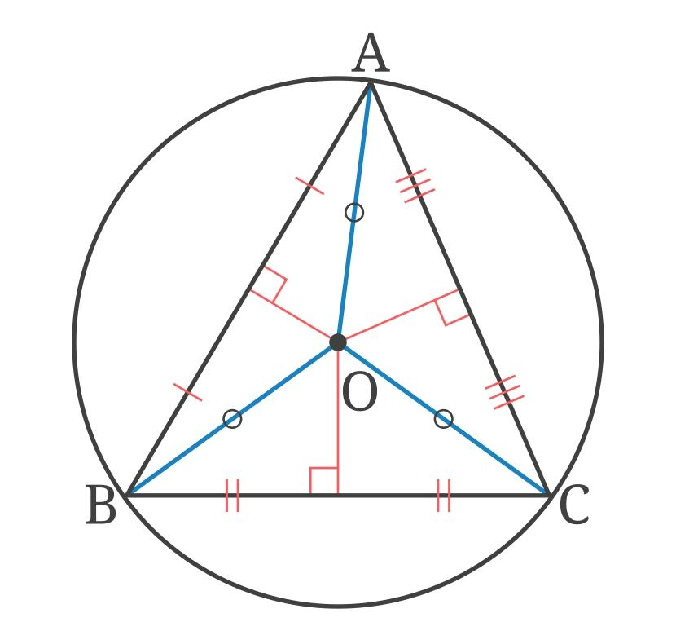
Image
​
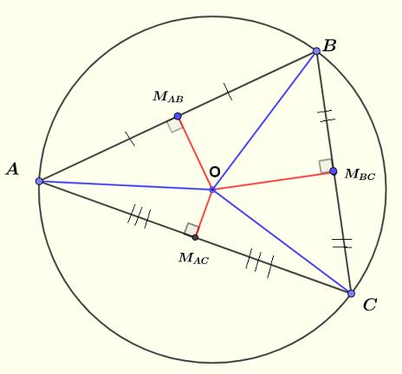
Image 2
​
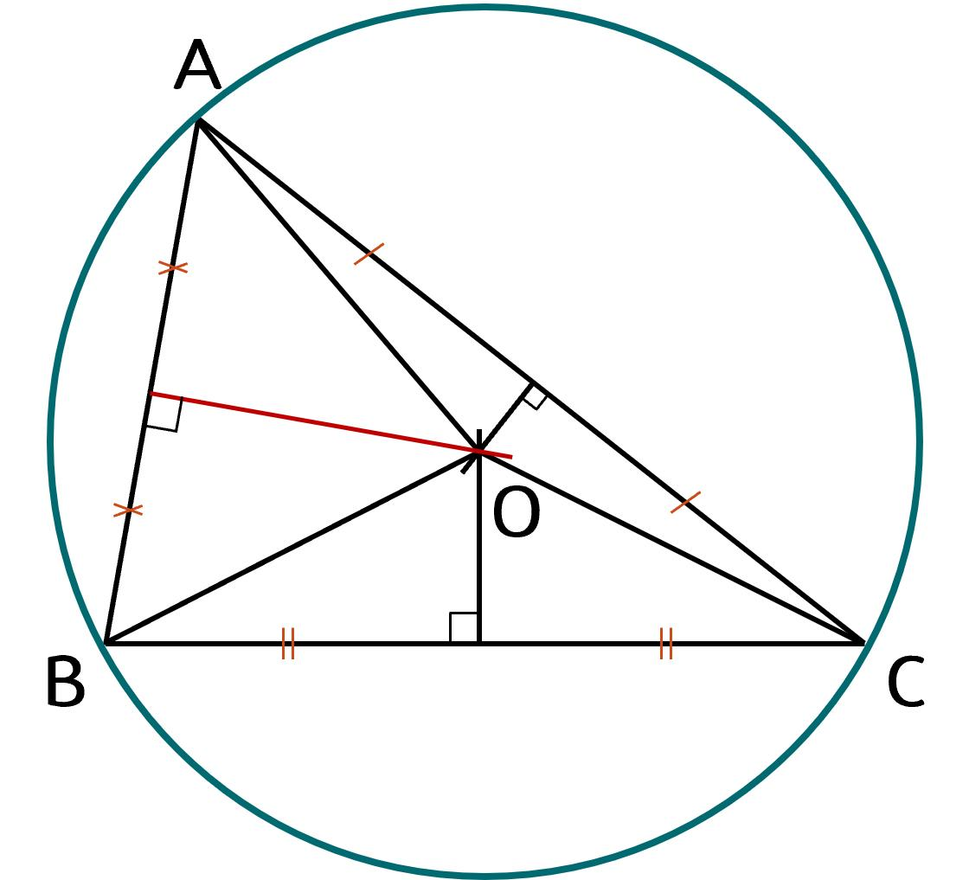
Image 3
​
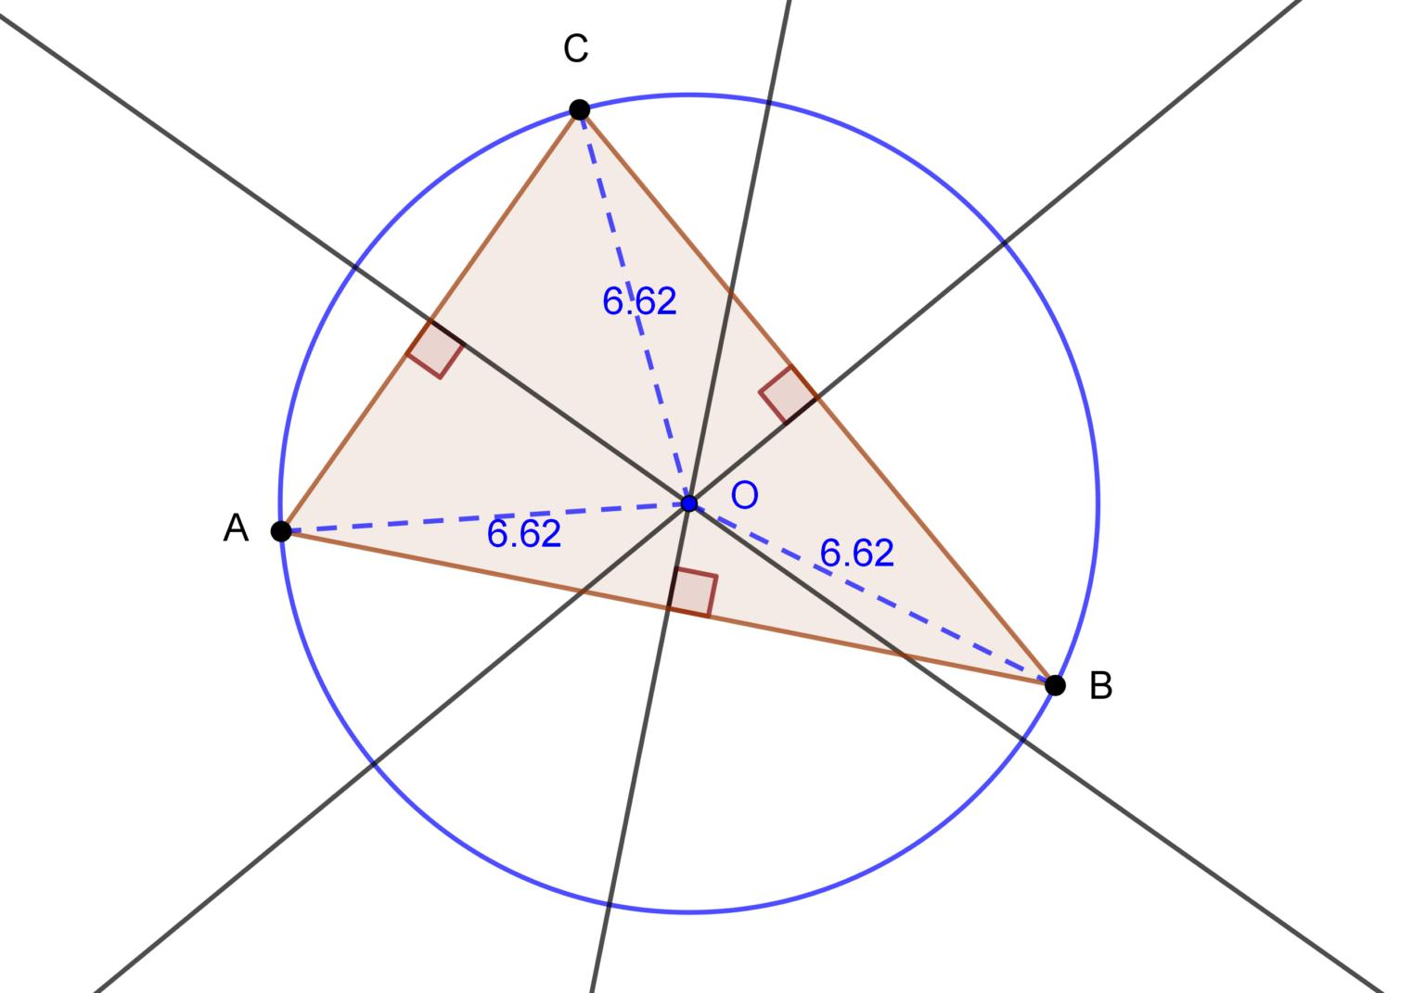
Image 4
​
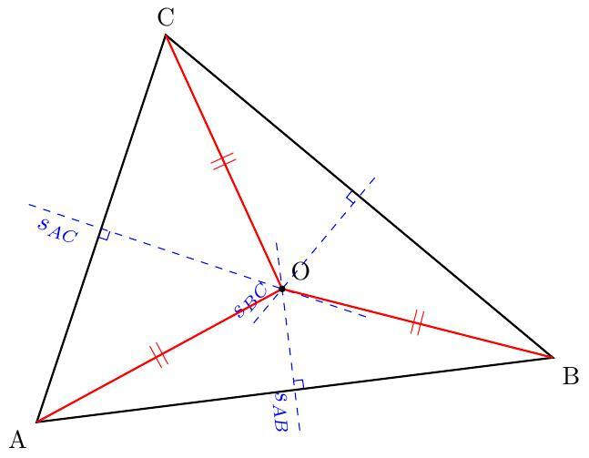
Image 5
They intersect at the circumcenter $O$.
By the Perpendicular Bisector Theorem:
$$OA=OB$$
because $O$ lies on the perpendicular bisector of $AB$.
Similarly:
$$OB=OC$$
and:
$$OC=OA$$
Therefore:
$$\boxed{OA=OB=OC}$$
This is why the circumcenter is the center of the circumcircle.

Relationship to the Circumcircle
# Source: AI Source: Provided by: [Data Path: Persons Table -> ID Column: 1, Name_En Column: Motasem Essam] -> From: [ChatGPT] on [7/25/2026]
Because:
$$OA=OB=OC$$
the three vertices $A,B,C$ are all the same distance from $O$.
Therefore, a circle centered at $O$ with radius $OA$ passes through all three vertices.
$$\boxed{OA=OB=OC=R}$$
where $R$ is the circumradius.

Perpendicular Bisector vs. Median
# Source: AI Source: Provided by: [Data Path: Persons Table -> ID Column: 1, Name_En Column: Motasem Essam] -> From: [ChatGPT] on [7/25/2026]
These concepts are related but different.
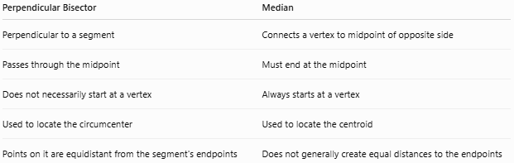
Perpendicular Bisector | Median
Perpendicular to a segment | Connects a vertex to midpoint of opposite side
Passes through the midpoint | Must end at the midpoint
Does not necessarily start at a vertex | Always starts at a vertex
Used to locate the circumcenter | Used to locate the centroid
Points on it are equidistant from the segment’s endpoints | Does not generally create equal distances to the endpoints

Important
A perpendicular bisector and a median can be the same line in special triangles, but they are not generally the same.

Perpendicular Bisector vs. Angle Bisector
# Source: AI Source: Provided by: [Data Path: Persons Table -> ID Column: 1, Name_En Column: Motasem Essam] -> From: [ChatGPT] on [7/25/2026]
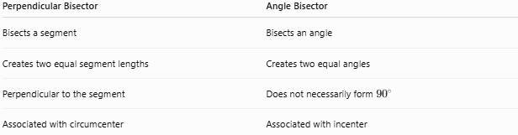
Perpendicular Bisector | Angle Bisector
Bisects a segment | Bisects an angle
Creates two equal segment lengths | Creates two equal angles
Perpendicular to the segment | Does not necessarily form ${90}^{∘}$
Associated with circumcenter | Associated with incenter

Coordinate Geometry
# Source: AI Source: Provided by: [Data Path: Persons Table -> ID Column: 1, Name_En Column: Motasem Essam] -> From: [ChatGPT] on [7/25/2026]
For a line segment with endpoints:
$$A(x_{1},y_{1})$$
and:
$$B(x_{2},y_{2})$$
the midpoint is:
$$\boxed{M=\left(\frac{x_{1}+x_{2}}{2},\frac{y_{1}+y_{2}}{2}\right)}$$
The slope of $AB$ is:
$$m_{AB}=\frac{y_{2}-y_{1}}{x_{2}-x_{1}}$$
The perpendicular bisector has a slope that is the negative reciprocal:
$$\boxed{m_{⟂}=-\frac{1}{m_{AB}}}$$
when $m_{AB}≠0$.
The equation of the perpendicular bisector can then be written using point-slope form:
$$\boxed{y-y_{M}=m_{⟂}(x-x_{M})}$$

Example 4: Coordinate Geometry
# Source: AI Source: Provided by: [Data Path: Persons Table -> ID Column: 1, Name_En Column: Motasem Essam] -> From: [ChatGPT] on [7/25/2026]
Let:
$$A(2,3)$$
and:
$$B(8,7)$$

Step 1: Find the midpoint
# Source: AI Source: Provided by: [Data Path: Persons Table -> ID Column: 1, Name_En Column: Motasem Essam] -> From: [ChatGPT] on [7/25/2026]
$$M=\left(\frac{2+8}{2},\frac{3+7}{2}\right)$$
$$M=(5,5)$$

Step 2: Find the slope of $AB$
# Source: AI Source: Provided by: [Data Path: Persons Table -> ID Column: 1, Name_En Column: Motasem Essam] -> From: [ChatGPT] on [7/25/2026]
$$m_{AB}=\frac{7-3}{8-2}$$
$$m_{AB}=\frac{4}{6}=\frac{2}{3}$$

Step 3: Find the perpendicular slope
# Source: AI Source: Provided by: [Data Path: Persons Table -> ID Column: 1, Name_En Column: Motasem Essam] -> From: [ChatGPT] on [7/25/2026]
$$m_{⟂}=-\frac{3}{2}$$

Step 4: Equation
# Source: AI Source: Provided by: [Data Path: Persons Table -> ID Column: 1, Name_En Column: Motasem Essam] -> From: [ChatGPT] on [7/25/2026]
Using $M(5,5)$:
$$y-5=-\frac{3}{2}(x-5)$$
Therefore:
$$\boxed{y-5=-\frac{3}{2}(x-5)}$$
is the perpendicular bisector of $\overline{AB}$.

Important Properties
# Source: AI Source: Provided by: [Data Path: Persons Table -> ID Column: 1, Name_En Column: Motasem Essam] -> From: [ChatGPT] on [7/25/2026]
Property 1: Every point on the perpendicular bisector is equidistant from the endpoints
$$\boxed{P∈\text{perpendicular bisector}⇒PA=PB}$$
Property 2: Equal distances identify the perpendicular bisector
$$\boxed{PA=PB⇒P∈\text{perpendicular bisector}}$$
Property 3: The perpendicular bisector passes through the midpoint
If $M$ is the midpoint:
$$\boxed{AM=MB}$$
Property 4: It is perpendicular to the segment
$$\boxed{PM⟂AB}$$

Real-World Applications
# Source: AI Source: Provided by: [Data Path: Persons Table -> ID Column: 1, Name_En Column: Motasem Essam] -> From: [ChatGPT] on [7/25/2026]
The theorem is useful in:
- Geometry construction — constructing perpendicular bisectors.
- Surveying — locating points equally distant from two locations.
- Navigation — determining equal-distance regions.
- Computer graphics — geometric calculations.
- Engineering — symmetric positioning.
- Architecture — locating centers and balanced positions.
- Location problems — finding a point equally distant from two fixed points.

Applications
# Source: AI Source: Provided by: [Data Path: Persons Table -> ID Column: 1, Name_En Column: Motasem Essam] -> From: [ChatGPT] on [7/25/2026]
The Perpendicular Bisector Theorem can be used to:
- Find unknown side lengths.
- Prove two distances are equal.
- Prove that a point lies on a perpendicular bisector.
- Locate a triangle’s circumcenter.
- Construct a circumcircle.
- Solve coordinate-geometry problems.
- Identify symmetry and equidistant points.

Advantages
# Source: AI Source: Provided by: [Data Path: Persons Table -> ID Column: 1, Name_En Column: Motasem Essam] -> From: [ChatGPT] on [7/25/2026]
- Provides a simple test for equal distances.
- Has a useful converse.
- Helps locate the circumcenter.
- Works in both synthetic and coordinate geometry.
- Useful for geometric constructions.
- Connects line segments with circles and triangle centers.

Limitations
# Source: AI Source: Provided by: [Data Path: Persons Table -> ID Column: 1, Name_En Column: Motasem Essam] -> From: [ChatGPT] on [7/25/2026]
- It applies specifically to the perpendicular bisector of a segment.
- Being on a median does not automatically imply equal distances from the endpoints.
- Being on an angle bisector does not generally imply equal distances from two arbitrary points.
- The theorem concerns distances to the endpoints of the same segment.

Comparison with Related Theorems
# Source: AI Source: Provided by: [Data Path: Persons Table -> ID Column: 1, Name_En Column: Motasem Essam] -> From: [ChatGPT] on [7/25/2026]
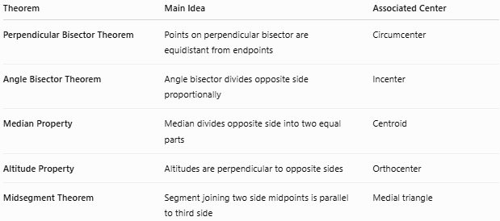
Theorem | Main Idea | Associated Center
Perpendicular Bisector Theorem | Points on perpendicular bisector are equidistant from endpoints | Circumcenter
Angle Bisector Theorem | Angle bisector divides opposite side proportionally | Incenter
Median Property | Median divides opposite side into two equal parts | Centroid
Altitude Property | Altitudes are perpendicular to opposite sides | Orthocenter
Midsegment Theorem | Segment joining two side midpoints is parallel to third side | Medial triangle

Key Points
# Source: AI Source: Provided by: [Data Path: Persons Table -> ID Column: 1, Name_En Column: Motasem Essam] -> From: [ChatGPT] on [7/25/2026]
- The Perpendicular Bisector Theorem states:
$$\boxed{P\text{ on perpendicular bisector of }AB⇒PA=PB}$$
- Its converse states:
$$\boxed{PA=PB⇒P\text{ lies on perpendicular bisector of }AB}$$
- A perpendicular bisector:
  - passes through the midpoint,
  - is perpendicular to the segment,
  - creates equal distances from the endpoints.
- The perpendicular bisectors of a triangle’s sides meet at the circumcenter.
- At the circumcenter:
$$\boxed{OA=OB=OC}$$
- The theorem is one of the fundamental tools for understanding the circumcenter and circumcircle.

Conclusion
# Source: AI Source: Provided by: [Data Path: Persons Table -> ID Column: 1, Name_En Column: Motasem Essam] -> From: [ChatGPT] on [7/25/2026]
The Perpendicular Bisector Theorem establishes a fundamental relationship between perpendicular bisectors and equal distances. Any point on the perpendicular bisector of a segment is equally distant from its two endpoints, and conversely, any point equally distant from those endpoints lies on the perpendicular bisector. This theorem is especially important in triangle geometry because it explains why the three perpendicular bisectors of a triangle meet at the circumcenter, which is equally distant from all three vertices.

